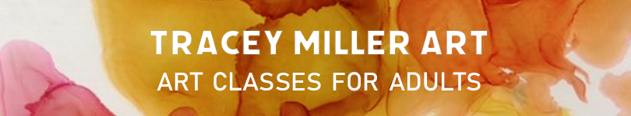

Beginners art workshop for adults.
We’ll do four structured sessions using four different mediums all in one day.
Tracey will guide beginner and intermediate artists through an exploration of various mediums.
For more information visit traceymillerart.com
We’ll create art works using mediums such as graphite, charcoal, pastel, collage and acrylic paint.
Have fun, explore, experiment and you’ll take home your own artistic treasures.
When: 10.00 am until 4.00 pm. Sunday 9 February, 2020
Where: Studio 1, BDAS, 1 Short St., Bowral.
Tutor: Tracey Miller See more information at Traceymillerart.com
Cost: $150. All materials are supplied.
Enrol: traceymillermail@gmail.com
All you need to bring is yourself and your lunch.

For beginners - we’ll create in charcoal, graphite, pastel, paint and collage.

